
Calculation Policy

Year 1
Addition | Subtraction | Multiplication | Division
- Adding 1-digit numbers within ten | - Subtract 1-digit numbers within ten | - Solve 1-step problems using multiplication | - Solve simple one-step problems using multiplication (sharing)
When adding numbers to 10, children can explore both aggregation and augmentation  The part-whole model, discrete and continuous bar model, number shapes and ten-frame support aggregation  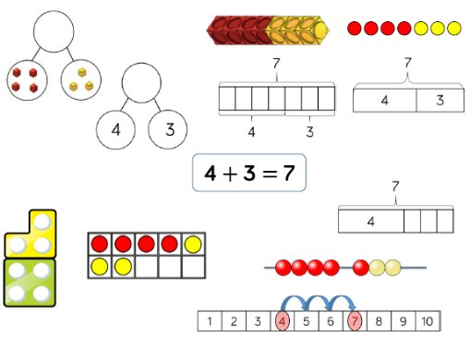  The combination bar model, ten frame bead strong and number track all support augmentation. | Part whole models, bar models, ten frames and number shapes support partitioning  Ten-frames, number tracks, single bar models and bead strings support reduction  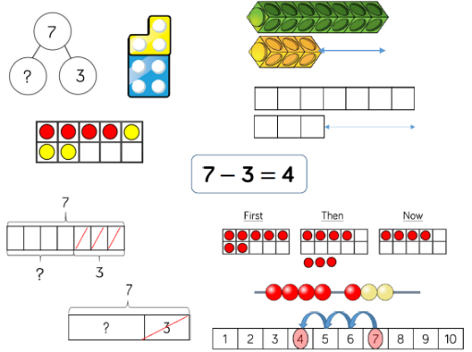  Cubes and bar models with two bars can support finding the difference | Children represent multiplication as repeated addition in many different ways.  In Year 1, children use concrete and pictorial representations to solve problems. They are not expected to record multiplication formally  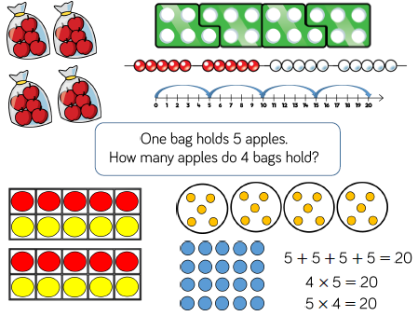  In Year 2, children are introduced to the multiplication symbol. | Children solve problems by sharing amounts into equal groups  In Year 1, children use concrete, and proctorial representations to solve problems. They are not expected to record division formally.  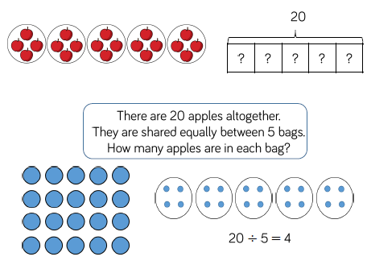  In Year 2, children are introduced to the division symbol.
- Add 1- and 2-digit numbers to 20 | 2) Subtract 1- and 2-digit numbers to 20 |  | 2) Solve 1-step problems using division (grouping)
When adding one-digit numbers that cross 10, it is important to highlight the importance of ten ones equalling one ten  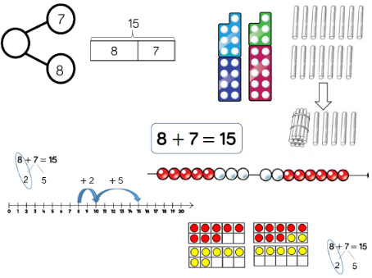  Different manipulatives can be used to represent this exchange. Use concrete resources alongside number line to support children in understanding how to partition their jumps. | When subtracting one-digit numbers that cross 10, it is important to highlight the importance of ten ones equally one ten  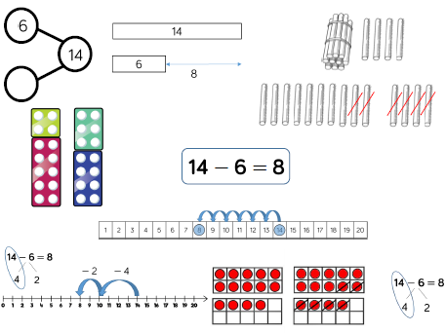  Children should be encouraged to find the number bond to 10 when partitioning the subtracted number. Ten frames, number shapes and number lines are useful for this. |  | 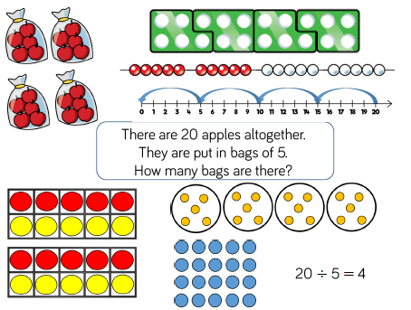  Children solve problems by grouping and counting the number of groups. Grouping encourages children to count in multiples and links to repeated subtraction on a number line. They can use concrete representations in fixed groups such as number shapes which helps to show the link between multiplication and division.
 |  |  | - Divide 2 digits by 1 digit (sharing with no exchange)
When dividing larger numbers, children can use manipulatives that allow them to partition into tens and ones

Straws, Base 10 and place value counters can all be used to share numbers into equal groups

Part-whole models can provide children with a clear written method that matches the concrete representation
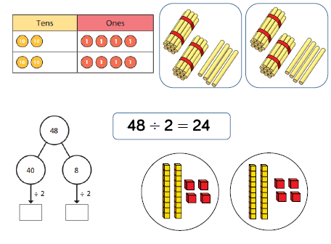

Year 2
Addition | Subtraction | Multiplication | Division
- Add 1- and 2-digit numbers to 20 | - Subtract 1- and 2-digit numbers to 20 | - 2 Times tables | - Solve simple 1-step problems using multiplication (sharing)
When adding one-digit numbers that cross 10, it is important to highlight the importance of ten ones equalling one ten  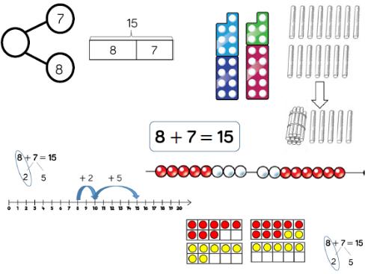  Different manipulatives can be used to represent this exchange. Use concrete resources alongside number line to support children in understanding how to partition their jumps. | When subtracting one-digit numbers that cross 10, it is important to highlight the importance of ten ones equally one ten  Children should be encouraged to find the number bond to 10 when partitioning the subtracted number. Ten frames, number shapes and number lines are useful for this. | Encourage daily counting in multiples both forwards and backwards. This can be supported using a number line or hundred squares.  Look for pattern in the two times table, using concrete, manipulatives to support. Notice how all the numbers are even and there is a pattern in the ones.  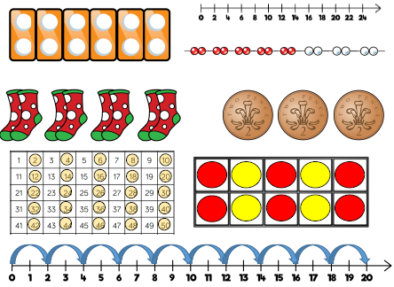  Use different models to develop fluency | Children solve problems by sharing amounts into equal groups  In Year 1, children use concrete, and proctorial representations to solve problems. They are not expected to record division formally.  In Year 2, children are introduced to the division symbol.
- Add three 1 digit numbers | 2) Subtract 1 and 2 digit numbers to 100 | - 5 times table | 2) Solve 1-step problems using division (grouping)
When adding three 1digit numbers, children should be encouraged to look for numbers bonds to 10 or doubles to add the numbers more efficiently  This supports children in their understanding of commutativity  Manipulatives that highlight number bonds to 10 are effective when adding three 1 digit numbers  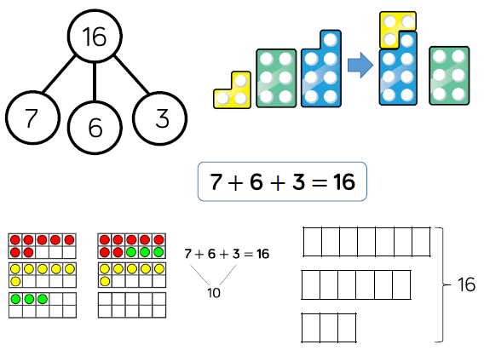 | At this stage, encourage chuldren to use the formal column method when calculating alonside straws, base 10 or place value counters. As numbers become larger, straws become less efficient  Children can also use a blank number line to count on to find the difference. Encourage them to jump to multiples of 1- to become more efficient.  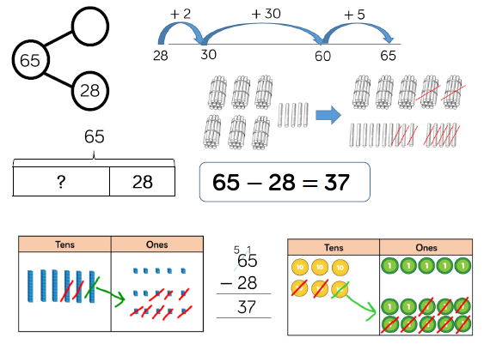 | Encourage daily counting in multiples both forwards and backwards. This can be supported using a number line or a hundred square  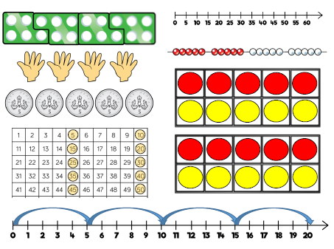  Look for patterns in the 5 times tables using concrete manipulatives. Notice the pattern in the ones as well as highlight the odd, even, odd, even pattern | Children solve problems by grouping and counting the number of groups. Grouping encourages children to count in multiples and links to repeated subtraction on a number line. They can use concrete representations in fixed groups such as number shapes which helps to show the link between multiplication and division.
3) Add 1 digit and 2 digit numbers to 100 |  | - 10 Times table | 3) Divide 2 digits by 1 digit (sharing with no exchange)
When adding single digits to a two-digit number, children should be encouraged to count on from the larger number  They should also apply their knowledge of number bonds to add more efficiently e.g. 8+5 = 13 so 38+5 = 43  Hundred squares and straws can support children to find the number bond to 10  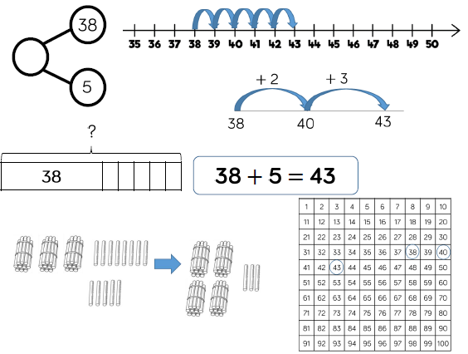 |  | Encourage daily counting in multiples both forwards and backwards. This can be supported using a number line or a hundred square  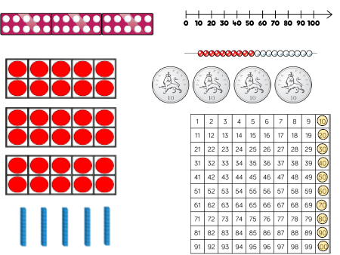  Look for patterns in the 5 times tables using concrete manipulatives. Notice the pattern in the digits, the ones are always 0, and the tens increase by 1 each time | When dividing larger numbers, children can use manipulatives that allow them to partition into tens and ones  Straws, Base 10 and place value counters can all be used to share numbers into equal groups  Part-whole models can provide children with a clear written method that matches the concrete representation
- Add two 2-digit numbers to 100 |  | 5) Solve 1-step problems using multiplication
At this stage, encourage children to use the formal column method when calculating alongside straws, base 10 or place value counters. As numbers become larger, straws become less efficient  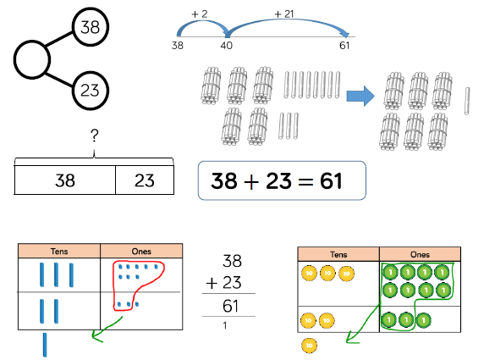 |  | Children represent multiplication as repeated addition in many different ways.  In Year 1, children use concrete and pictoral representations to solve problems. They are not expected to record multiplication formally  In Year 2, children are introduced to the multiplication symbol.

Year 3

Addition | Subtraction | Multiplication | Division
- Add 1 digit and 2 digit numbers to 100 | - Subtract numbers with up to 3 digits | - 3 times table | - Divide 2 digits by 1-digit (sharing with exchange)
When adding single digits to a two-digit number, children should be encouraged to count on from the larger number  They should also apply their knowledge of number bonds to add more efficiently e.g. 8+5 = 13 so 38+5 = 43  Hundred squares and straws can support children to find the number bond to 10 | Base 10 and place value counters are the most effective manipulative when subtracting numbers with up to 3 digits  Ensure children write alongside any concrete resources so they can see the links to the written column method  Plain counters on a place value grid can also be used to support learning  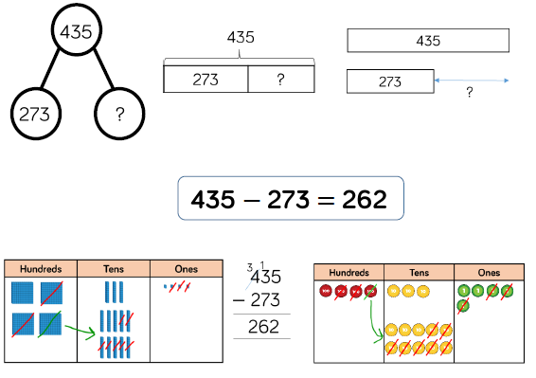 | Encourage daily counting multiples both forwards and backwards. This can be supported using a number line or a hundred square  Look for patterns in the three times table using concrete manipulatives to support. Notice the odd, even odd, even pattern using number shapes to support. Highlight the pattern in the ones using a hundreds square.  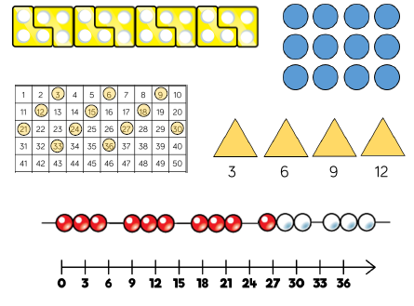 | When dividing numbers involving an exchange, children can use Base 10 and place value counters to exchange one ten for ten ones.  Children should start with the equipment outside the place value grid before sharing the tens and ones equally between the rows.  Flexible partitioning in a part-whole model supports this method.  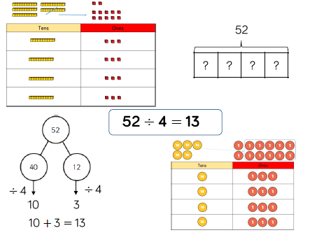
- Add two 2-digit numbers to 100 |  | 2) 4 times table | 2) Divide 2-digits by 1-digit (sharing with remainders)
At this stage, encourage children to use the formal column method when calculating alongside straws, base 10 or place value counters. As numbers become larger, straws become less efficient |  | Encourage daily counting multiples both forwards and backwards. This can be supported using a number line or a hundred square  Look for patterns in the three times table using concrete manipulatives to support. Make links to the 2 times table, seeing how each multiple is double the twos. Notice the pattern in the ones within each group of five multiples. Highlight that all the multiples are even using number shapes to support.  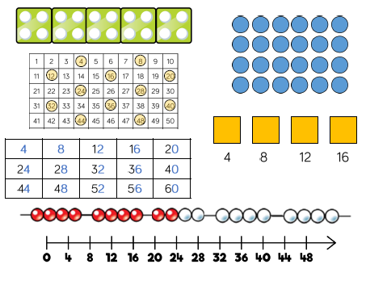 | When dividing numbers with remainders, children can use Base 10 and place value counters to exchange one ten for ten ones.  Starting with the equipment outside the place value grid will highlight remainders, as they will be left outside the grid once the equal groups have been made.  Flexible partitioning in a part-whole model supports this method.  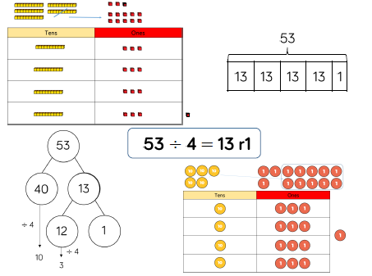
- Add numbers with up to 3 digits |  | 3) 8 times table
Base 10 and place value counters are the most effective manipulatives when adding numbers with up to 3 digits  Ensure children write out their calculation alongside any concrete resources so they can see the links to the the written column method  Plain counters on a place value grif can also be used to support learning  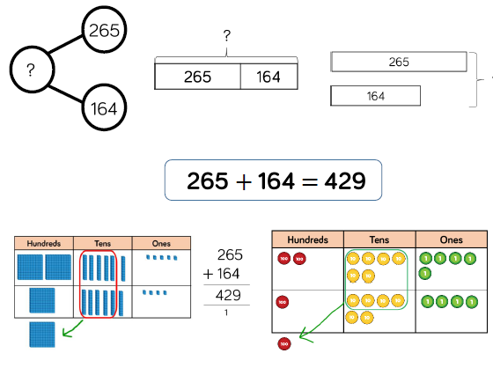 |  | Encourage daily counting multiples both forwards and backwards. This can be supported using a number line or a hundred square  Look for patterns in the three times table using concrete manipulatives to support. Make links to the 4 times table, seeing how each multiple is double the fours. Notice the pattern in the ones within each group of five multiples. Highlight that all the multiples are even using number shapes to support.  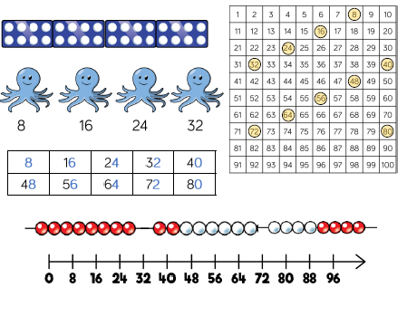
 |  | - Multiply 2 digits by 1 digit numbers
Teachers may want to first look at the expanded column method before moving on to the short multiplication method.

The place value counters should be used to support the understanding of the method rather than supporting the multiplication, as children should use times table knowledge.
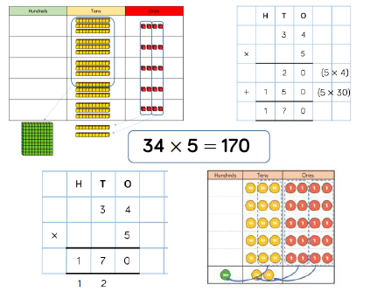
 |  | - Multiply 3 digit numbers by 1 digit numbers
When moving to 3-digit by 1-digit multiplication, encourage children to move towards the short, formal written method.

Base 10 and place value counters continue to support the understanding of the written method. Limit the number of exchanges needed in the questions and move the children away from resources when multiplying larger numbers.
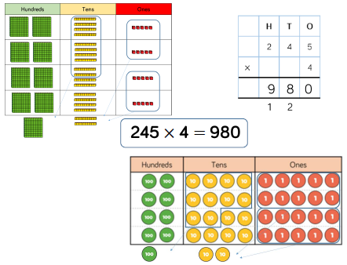

Year 4
Addition | Subtraction | Multiplication | Division
- Add numbers with up to 4 digits | - Subtract numbers with up to 4 digits | - 6 times table | - Divide 2 digits by 1-digit (sharing with exchange)
Base 10 and place value counters are the most effective manipulatives when adding numbers with up to 4 digits  Ensure children write out their calculation alongside any concrete resources so they can see the links to the written column method  Plain counters on a place value grid can also be used to support learning.  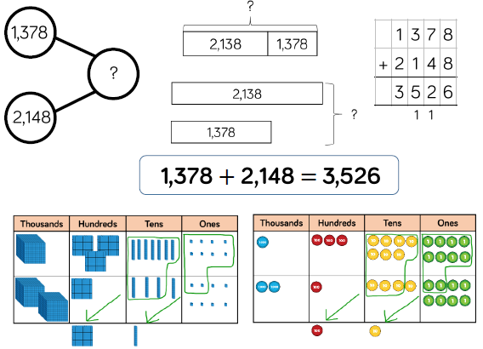 | Base 10 and place value counters are the most effective manipulatives when subtracting numbers with up to 4 digits  Ensure children write out their calculation alongside any concrete resources so they can see the links to the written column method  Plain counters on a place value grid can also be used to support learning.  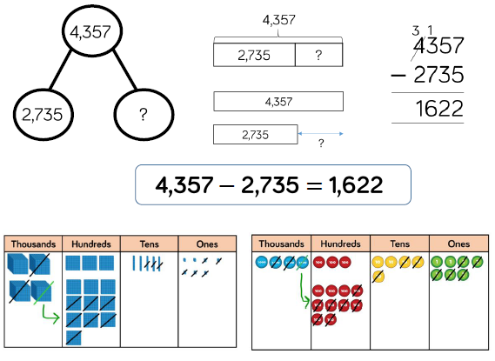 | Encourage daily counting multiples both forwards and backwards. This can be supported using a number line or a hundred square  Look for patterns in the three times table using concrete manipulatives to support. Make links to the 3 times table. Seeing how each multiple is double the threes. Notice the pattern in the ones within each group of five multiples. Highlight that all the multiples are even using number shapes to support.  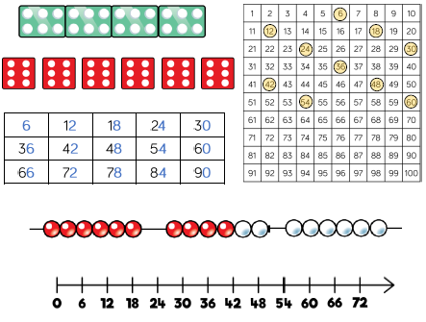 | When dividing numbers involving an exchange, children can use Base 10 and place value counters to exchange one ten for ten ones.  Children should start with the equipment outside the place value grid before sharing the tens and ones equally between the rows.  Flexible partitioning in a part-whole model supports this method.
 |  | - 9 times table | 2) Divide 2-digits by 1-digit (sharing with remainders)
 |  | Encourage daily counting multiples both forwards and backwards. This can be supported using a number line or a hundred square  Look for patterns in the three times table using concrete manipulatives to support. Look for patterns in the nines times table, using concrete manipulatives to support. Notice the pattern in the tens and ones using the hundred square to support as well as noting the odd, even pattern within the multiples.  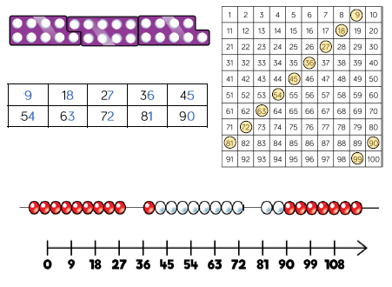 | When dividing numbers with remainders, children can use Base 10 and place value counters to exchange one ten for ten ones.  Starting with the equipment outside the place value grid will highlight remainders, as they will be left outside the grid once the equal groups have been made.  Flexible partitioning in a part-whole model supports this method.
 |  | - 7 times table | 3) Divide 2 digits by 1 digit (grouping)
 |  | Encourage daily counting multiples both forwards and backwards. This can be supported using a number line or a hundred square  Look for patterns in the three times table using concrete manipulatives to support. The seven times table can be trickier to learn due to the lack of obvious pattern in the numbers, however they already know several facts due to commutativity.  Children can still see the odd, even pattern in the multiples using number shapes to support.  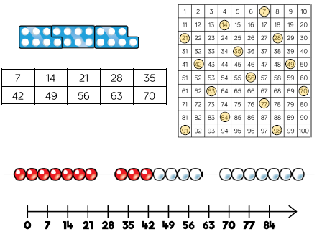 | When using the short division method, children use grouping. Starting with the largest place value, they group by the divisor.  Language is important here. Children should consider ‘How many groups of 4 tens can we make?’ and ‘How many groups of 4 ones can we make?’  Remainders can also be seen as they are left ungrouped.  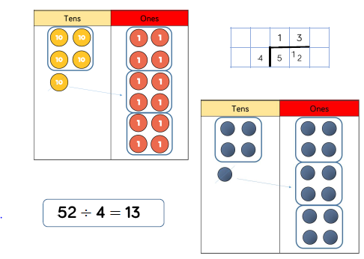
 |  | - 11 times table | 4) Divide 3 digits by 1 digit (sharing)
 |  | Encourage daily counting multiples both forwards and backwards. This can be supported using a number line or a hundred square  Look for patterns in the three times table using concrete manipulatives to support. Notice the pattern in the tens and ones using the hundred square to support. Also consider the pattern after crossing 100.  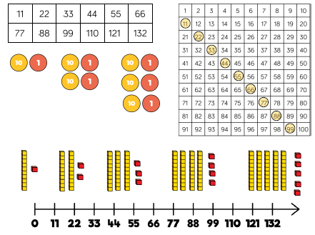 | Children can continue to use place value counters to share 3-digit numbers into equal groups. Children should start with the equipment outside the place value grid before sharing the hundreds, tens and one equally between the rows.  This method can also help to highlight remainders.  Flexible partitioning in a part-whole model supports this method.  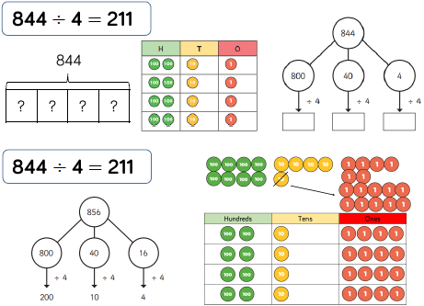
 |  | - 12 times table
Encourage daily counting multiples both forwards and backwards. This can be supported using a number line or a hundred square

Look for patterns in the three times table using concrete manipulatives to support. Make links to the 6 times table, seeing how each multiple is double the sixes. Notice the pattern in the ones within each group of five multiples. The hundred square can support in highlighting this pattern.
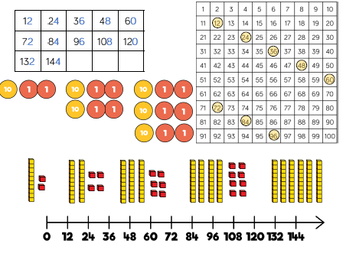
 |  | - Multiply 2 digits by 1 digit numbers
Teachers may want to first look at the expanded column method before moving on to the short multiplication method.

The place value counters should be used to support the understanding of the method rather than supporting the multiplication, as children should use times table knowledge.
 |  | - Multiply 3 digit numbers by 1 digit numbers
When moving to 3-digit by 1-digit multiplication, encourage children to move towards the short, formal written method.

Base 10 and place value counters continue to support the understanding of the written method. Limit the number of exchanges needed in the questions and move the children away from resources when multiplying larger numbers.

Year 5
Addition | Subtraction | Multiplication | Division
- Add numbers with more than 4 digits | - Subtract numbers with more than 4 digits | 1) Multiply 4-digit numbers by 1-digit numbers | 1) Divide 2 digits by 1 digit (grouping)
Place value counters or plain counters on a place value grid are the most effective concrete resources when adding numbers with more than 4 digits.  At this stage, children should be encouraged to work in the abstract, using the column method to add larger numbers efficiently.  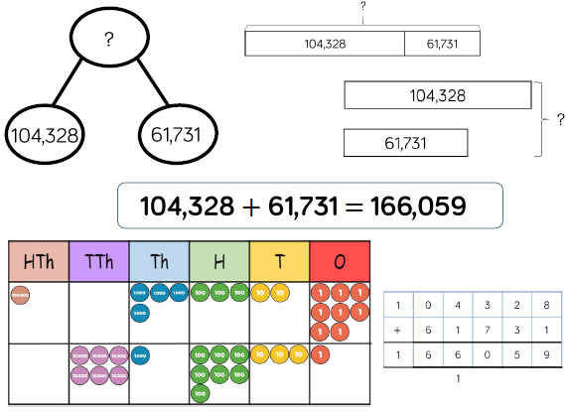 | Place value counters or plain counters on a place value grid are the most effective concrete resource when subtracting numbers with more than 4 digits  At this stage, children should be encouraged to work in the abstract, using column method to subtract larger numbers efficiently.  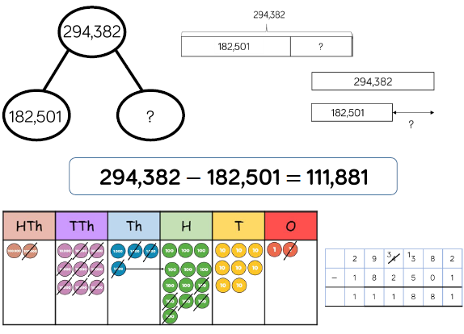 | When multiplying 4-digit numbers, place the value counters are the best manipulative to use to support children in their understanding of the formal written method. If children are multiplying larger numbers and struggling with their times tables, encourage the use of multiplication grids so children can focus on the use of the written method.  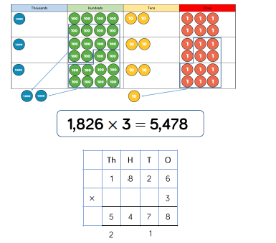 | When using the short division method, children use grouping. Starting with the largest place value, they group by the divisor.  Language is important here. Children should consider ‘How many groups of 4 tens can we make?’ and ‘How many groups of 4 ones can we make?’  Remainders can also be seen as they are left ungrouped.
- Add with up to 3 decimal places | 2) Subtract with up to 3 decimal places | 2) Multiply 2 digit numbers by a 2-digit numbers | 2) Divide 3 digits by 1 digit (grouping)
Place value counters on a place value grid are the most effective manipulative when subtracting decimals with 1,2, and then 3 decimal places.  Ensure children have experience of subtracting decimals with a variety of decimal places. This includes putting this into context when adding money and other measures.  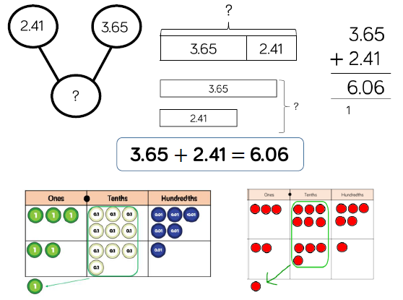 | Place value counters on a place value grid are the most effective manipulative when subtracting decimals with 1,2, and then 3 decimal places.  Ensure children have experience of subtracting decimals with a variety of decimal places. This includes putting this into contect when subtracting money and other measures.  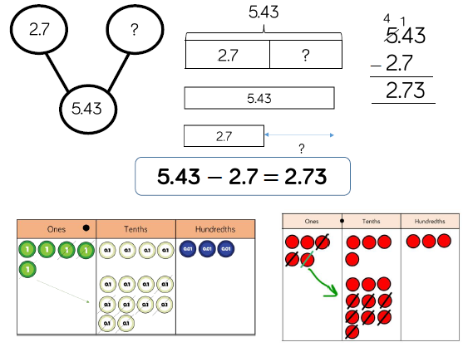 | When multiplying a multi-digit number by a 2-digits, use the area model to help children understand the size of the numbers they are using. This links to finding the area of a rectangle by finding the space covered by the Base 10.  The grid method matches the area model as an intial written method before moving on to the formal written multiplication model.  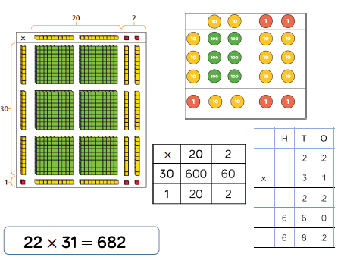 | Children can continue to use grouping to support their understanding of short division when dividing 3-digit numbers by a 1-digit number  Place value counters or plain counters can be used on a place value grid to support this understanding. Children can also draw their own counters and group them through a more pictorial method.  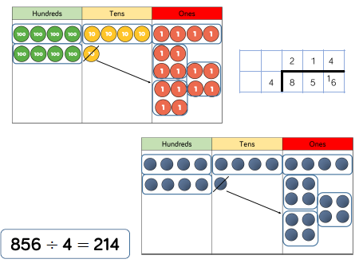
 |  | - Multiply 3-digit numbers by 2-digit numbers | 3) Divide 4 digits by 1-digit (grouping)
 |  | Children can continue to use the area model when mutliplying 3-digits by 2-digits. Place value counters become more efficient to use but Base 1- can be used to highlight the size of numbers.  Encourage children to move towards the formal written method, seeing the links with the grid method.  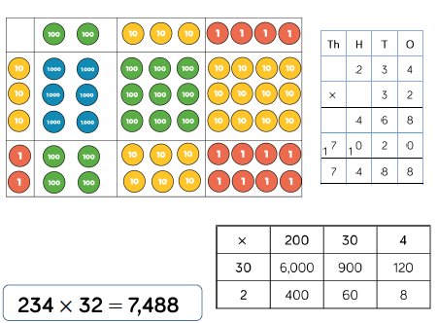 | Place value counters or plain counters can be used on a place value grid to support children to divide 4-digits by 1-digit. Children can also draw their own counters and group them through a more pictorial method.  Children should be encouraged to move away from the concrete and pictorial when dividing numbers with multiple exchanges.  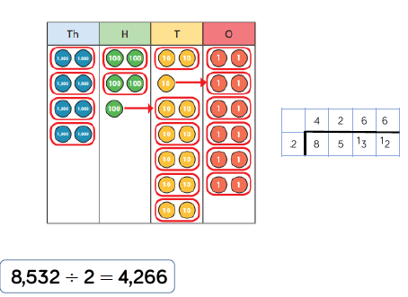
 |  | 4) Multiply 4-digit numbers by 2-digit numbers
When mutliplying 4-digit numbers by 2-digits children should be confident in the written method

If they are struggling with times tables, provide multiplication grids to support when they are focusing on the method.

Consider where exchanged digits are places and make sure this is consistent.
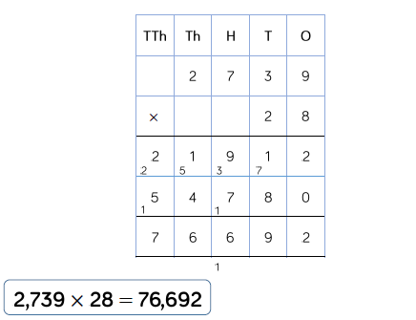

Year 6
Addition | Subtraction | Multiplication | Division
 | 1) Subtract numbers with more than 4 digits | 1) Multiply 4-digit numbers by 2-digit numbers | 1) Divide multi digits by 2 digits (short division)
 | Place value counters or plain counters on a place value grid are the most effective concrete resource when subtracting numbers with more than 4 digits  At this stage, children should be encouraged to work in the abstract, using column method to subtract larger numbers efficiently. | When mutliplying 4-digit numbers by 2-digits children should be confident in the written method  If they are struggling with times tables, provide multiplication grids to support when they are focusing on the method.  Consider where exchanged digits are places and make sure this is consistent. | When children begin to divide up to 4 digits by 2 digits, written methods become the most accurate as concrete and pictorial representation become less effective. Children can write out multiples to support their calculation with larger remainders. Children will also solve problems with remainders where the quotient can be rounded as appropriate.  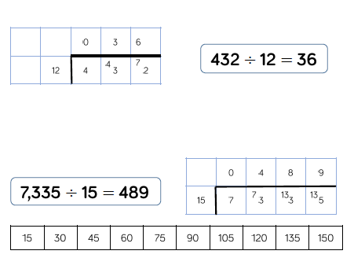
 |  |  | - Divide multi-digits by 2-digits (long division)
When a remainder is left at the end of a calculation, children can either leave it as a remainder or convert it to a fraction. This will depend on the context of the question.

Children can also answer questions where the quotient needed to be rounded according to the context.
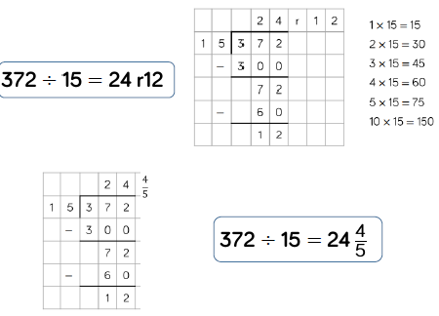

Appendix 1.

Glossary of terms: Addition and Subtraction
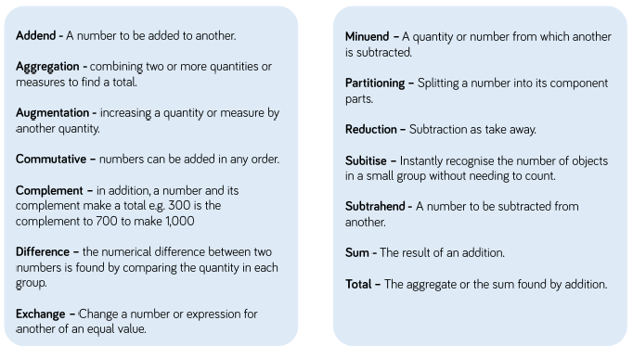

Appendix 2.

Glossary of terms: Multiplication and division


