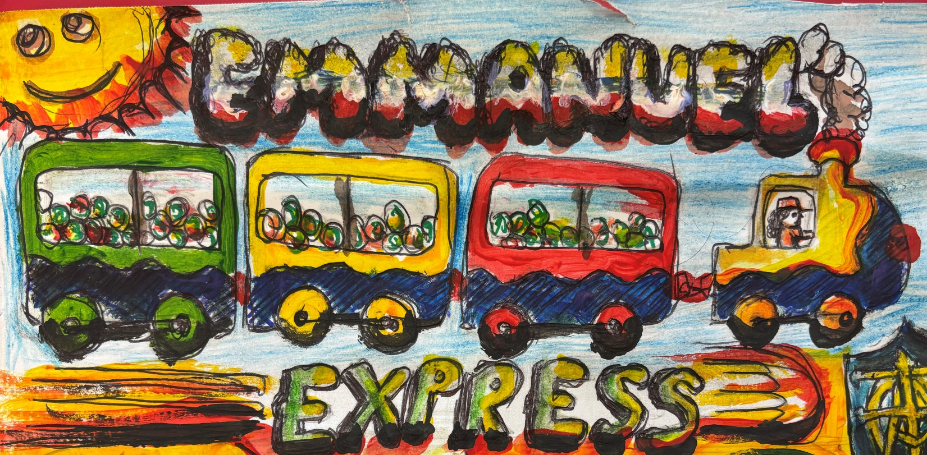
Emmanuel Express Pupil Newspaper - Issue #52 – July 2025


It’s Annie! Y6’s & Y5’s production!

by Quinn, Y6

Year 6 have been very busy this term practicing for their production. We will be performing it to parents on Wednesday.

When we were deciding who would claim the role as Annie and we thought two girls (Mia and Gabriella) were so good in the audition so we decided to have two Annie’s!




And during the show, we have a little surprise for everybody! Hope you enjoy the show!

A note from our Emmanuel Express Managers…
Thank you to all the Class Reps who have helped to write this newspaper. This term it was great to also have Year 1 Class Reps join the team! We hope you enjoy this edition of the Emmanuel Express. Happy Reading! From all the Express Team Managers – Kaede, Cody and Quinn
Thank you to our Summer term Class Reps:
Year 1 – Keira and Aksel
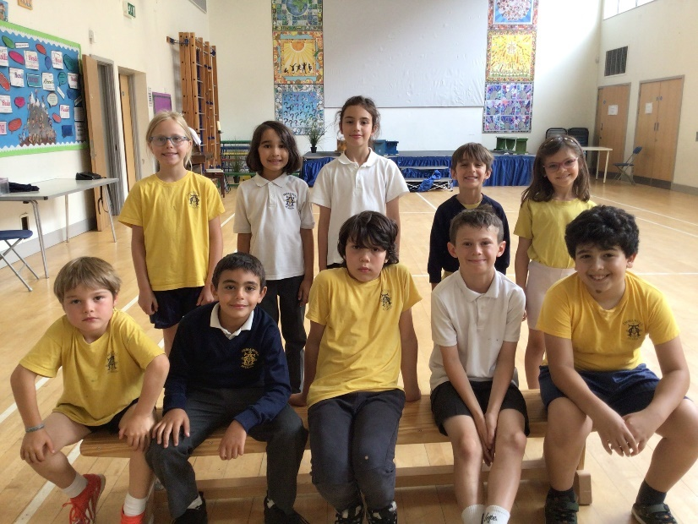
Year 2 – Hugo and William
Year 3 – Clara and Dias
Year 4 – Kiran and Martina

Year 5 – Noah and Eric



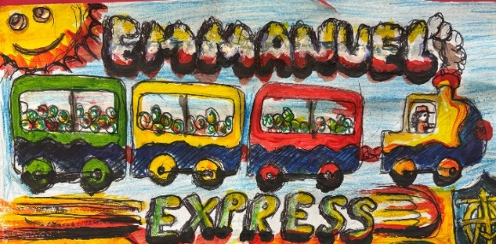
Well done to our front page design competition winner – Tiggy in Y5!

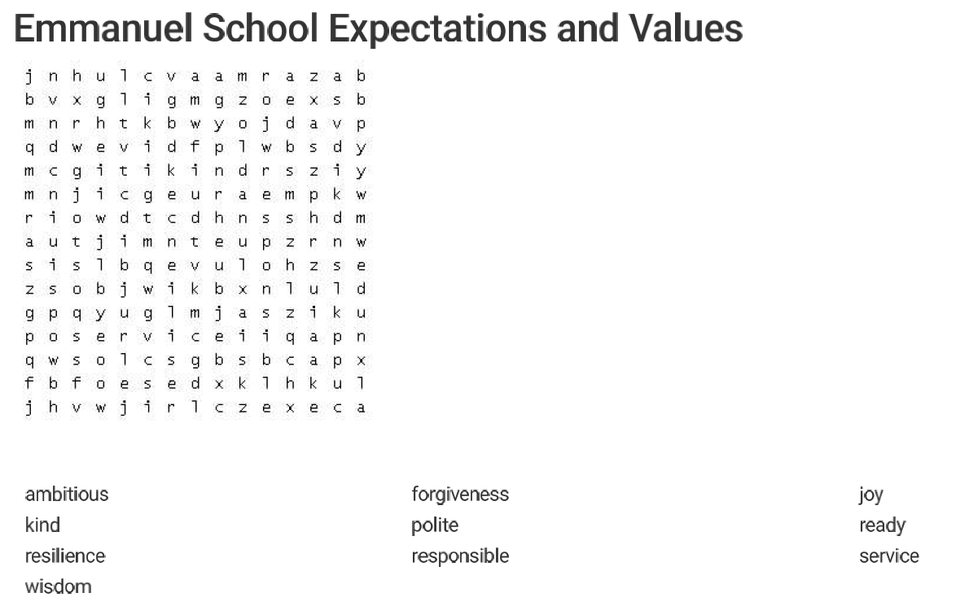
Wordsearch by Aksel and Keira, Y1

All about MINECRAFT by Daniel, Y4
(Please note: only available for children with parent permission from age 7+)
Minecraft is a blocky game where you can build whatever you want! You can also challenge yourself like playing hardcore mode where you only have one heart! So spare yourself in hardcore! There are many different mods that you can find in the marketplace. But some things in the marketplace cost minecoins. Minecoins are basically in game money BUT they cost real money. But don’t worry if you don’t have minecoins. There are some Mods/maps that are free! But the most common one is Minecraft education.
Rules

So reader, here's the thing that I forgot to tell you about, There aren't really any rules but still there are some. 1) Players can’t cheat in your multiplayer world if you set it so. 2) Minecraft was expecting you to kill the Ender dragon. 3) relax and build endless possibilities!
Character glossary
1. Zombie - A classical
2. Pillager - A hostile version of the villager
3.Phantom - A ghost zombie? But they hunt in the day!
4.Warden - A very strong one!
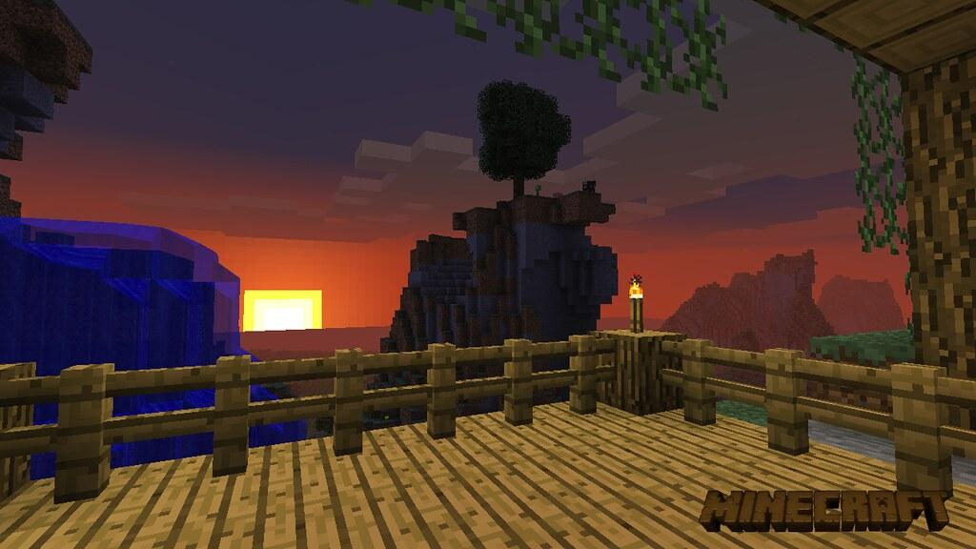
5.Blaze - He is burning hot!
6.Creeper - 3,2,1 Explode!
7.Ghast - Shoots fireballs
8.Endermite - Enderman’s pet
9.Enderman - Teleports anywhere
10.Elder guardian - Guards the sea
11.Evoker - You shall rule the pillagers!

Totally random facts
So, there are about a million facts about Minecraft on YouTube but here are some. 1) In some seeds you will see a scary face. 2) For you to start playing with friends you have to create a Microsoft account. 3) If you are playing on a PC you will be in java edition but on mobile devices you will be in bedrock.
Thank you for reading!!
Super summer word search by Athina, Y4
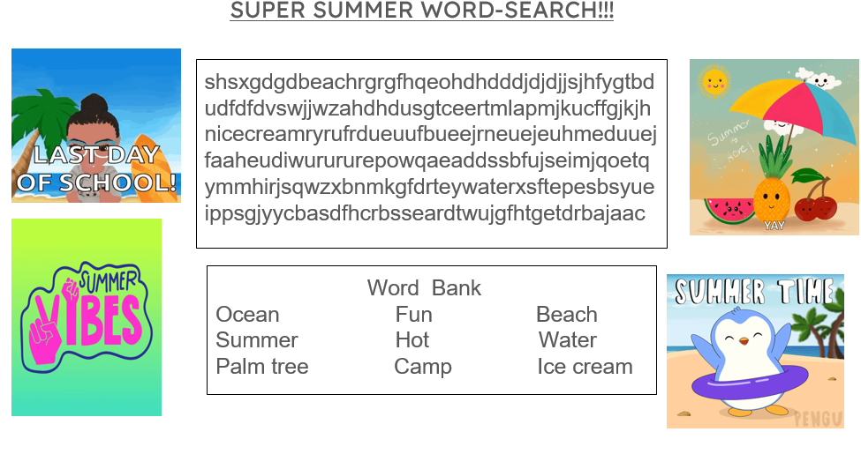
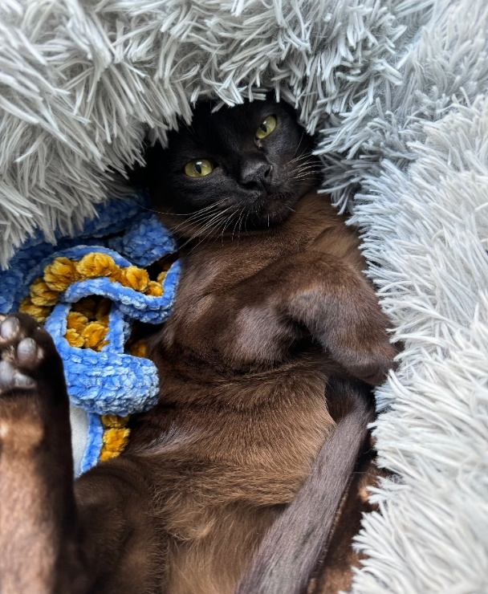
Burmese fact file by Martina and Kiran, Y4
Burmese cats have been around 1930s originating from Burma or now known as Myanmar. It traces back to a cat named Wang Mau was brought to the United States. Usually Burmese cats are playful, affectionate and they like to be surrounded by people. They are like dogs for their loyalty and their playfulness. They are curious and social.
They are great with families, children, other cats and even dogs. They don’t like to be left alone. Their life span is 14 to 16 years but they can live longer if treated nicely.
Burmese cats are bred by Siamese cats and Burmese to make a baby Burmese cat. They can also come in white or brown. The white variation looks more like the Siamese cat. I recommend this breed if you get a cat because they are cute and playful.
This is Martina’s cat!

Gaming review: Grow a garden by Eric and Noah, Y5
(Please note that Roblox is age 7+ with parent permission)

Starting game
Grow a garden is an experience found on the platform of Roblox. Grow a garden is a game about growing a garden. In Grow a garden you start off with £20. With those £20 you have enough money to buy two carrot seeds from the seed shop. With the two carrot seeds you can plant them so they grow. When they grow you pick them up and sell them for more money, then with that new found money you can buy more seeds then plant them and then sell them again and the cycle continues. While the cycle continues you can slowly get better seeds.

Later game


The middle stage of the game is focused on gear, pets and eggs. Like seeds you need to get the stuff from the shops. The gear is items the player will need to help them like a watering can to make the growth stage faster. And also sprinklers - there are 4 variants - some increase growth, some increase mutation we will get onto that later in the paragraph. Pets have certain abilities which lets you progress through the game e.g. the golden Labrador digs up seeds for free like sugar apples (best seed) and there’s more pets too! Lastly, there is gears, what gears do is like pets, you get certain abilities but most gears are only one time (one time is when you can only use once).

Statistics and benefits of playing the game
Grow a garden is a massive game with around 12.21 billion visits but when this comes out it will probably be at 14 billion visits. 12.21 billion visits has made the creators them around £30 million. Some people might say “This game is bad for people!” but many people would say this game is the exact opposite of this because we think this game helps people wonder “Should I buy this or save up more money?” or “Is this just a purchase I want or something that will get me more money?” so we think this game will help people think better about business and economics. Lastly, this game has blown up getting around 2.3-2.9 million players as their average player base at any given time, also this game passed a very massive game in more players at once coming in at a massive 21 million players.
Thank you for reading!
Quizzes by Aksel, Y1
a. If the code for HEART is WHTZY, what are the codes for the following words:
HER
TEAR
RAT

b. Answer these times tables questions:
2 x 5
3 x 10
60 x 100

c. Do you know the answers to these science questions?
i. Solar system: Is Pluto a planet? If not, what is it? Explain your answer.
ii. Human body: Why are lungs important?
iii. Animals (including humans): Can any animal live without food or water for 30 years?
iv. Materials: Which lasts longer, wood or metal?

English Quiz
- What is the right punctuation to end this sentence?
Do you like mangoes or apples
- Period b. comma c. exclamation mark d. question mark

- Fill in the gap with the most appropriate word:

The [ ] lights were so bright that they hurt my eyes.
a.Ominous b. dazzling c. faint d. blistering

- Circle the words that are opposites:
sheepish
lanky
bold
scrawny

- Circle the words that are synonyms:
devious
colossal
assertive
confident

Akel’s story: Emmanuel Cake Robbery
It was the last day of school, and everyone was excited because they wanted to play with their friends over the holidays. There would be a humongous rainbow cake for everybody after Collective Worship. It was a circular, six-tiered cake with pink frosting. Miss Roscoe asked Ben, Lara, Eighla, and Leon from Year Four to take the cake into the hall. After five minutes, they all came to class except Ben. Eighla told Miss Roscoe that Ben went to the toilet. Ten minutes later Ben came back.

Finally, it was 2:55pm! Everyone dashed into the hall because they were eager to eat the cake after Collective Worship. When everybody got into the hall, they were very shocked to see that a seventh of the cake had been eaten. Ben and Leon said that on their way into the hall, they saw a friendly, brown puppy running out. They tried to catch it but it slipped out of their hands. Year One and Two said that they saw it too. Then everybody understood it was the puppy that ate a bit of the cake. Everyone was disappointed because the teachers wouldn’t let them have the cake in case the puppy had licked it in other places.

Then Miss Roscoe started Collective Worship and changed her plans to cheer everyone up. Suddenly Ben jumped up and ran to the nearest teacher to ask if he could go to the toilet because he was sick, but he couldn’t make it. One step later, he vomited rainbow colours all over the clean floor! Everybody was surprised but then turned angry because they knew he had eaten the cake. Then all the children, except Ben, were happy because they could now eat the cake and Ben went home with a tummy ache.
True or false quiz by Clara and Dias, Year 3
- A tomato is a vegetable

- Light travels around corners

- A human is a mammal


- The universe has an end

- The earth is smaller than the sun

Answers are on the back page!

Cartoon comic by Baldur, Year 4
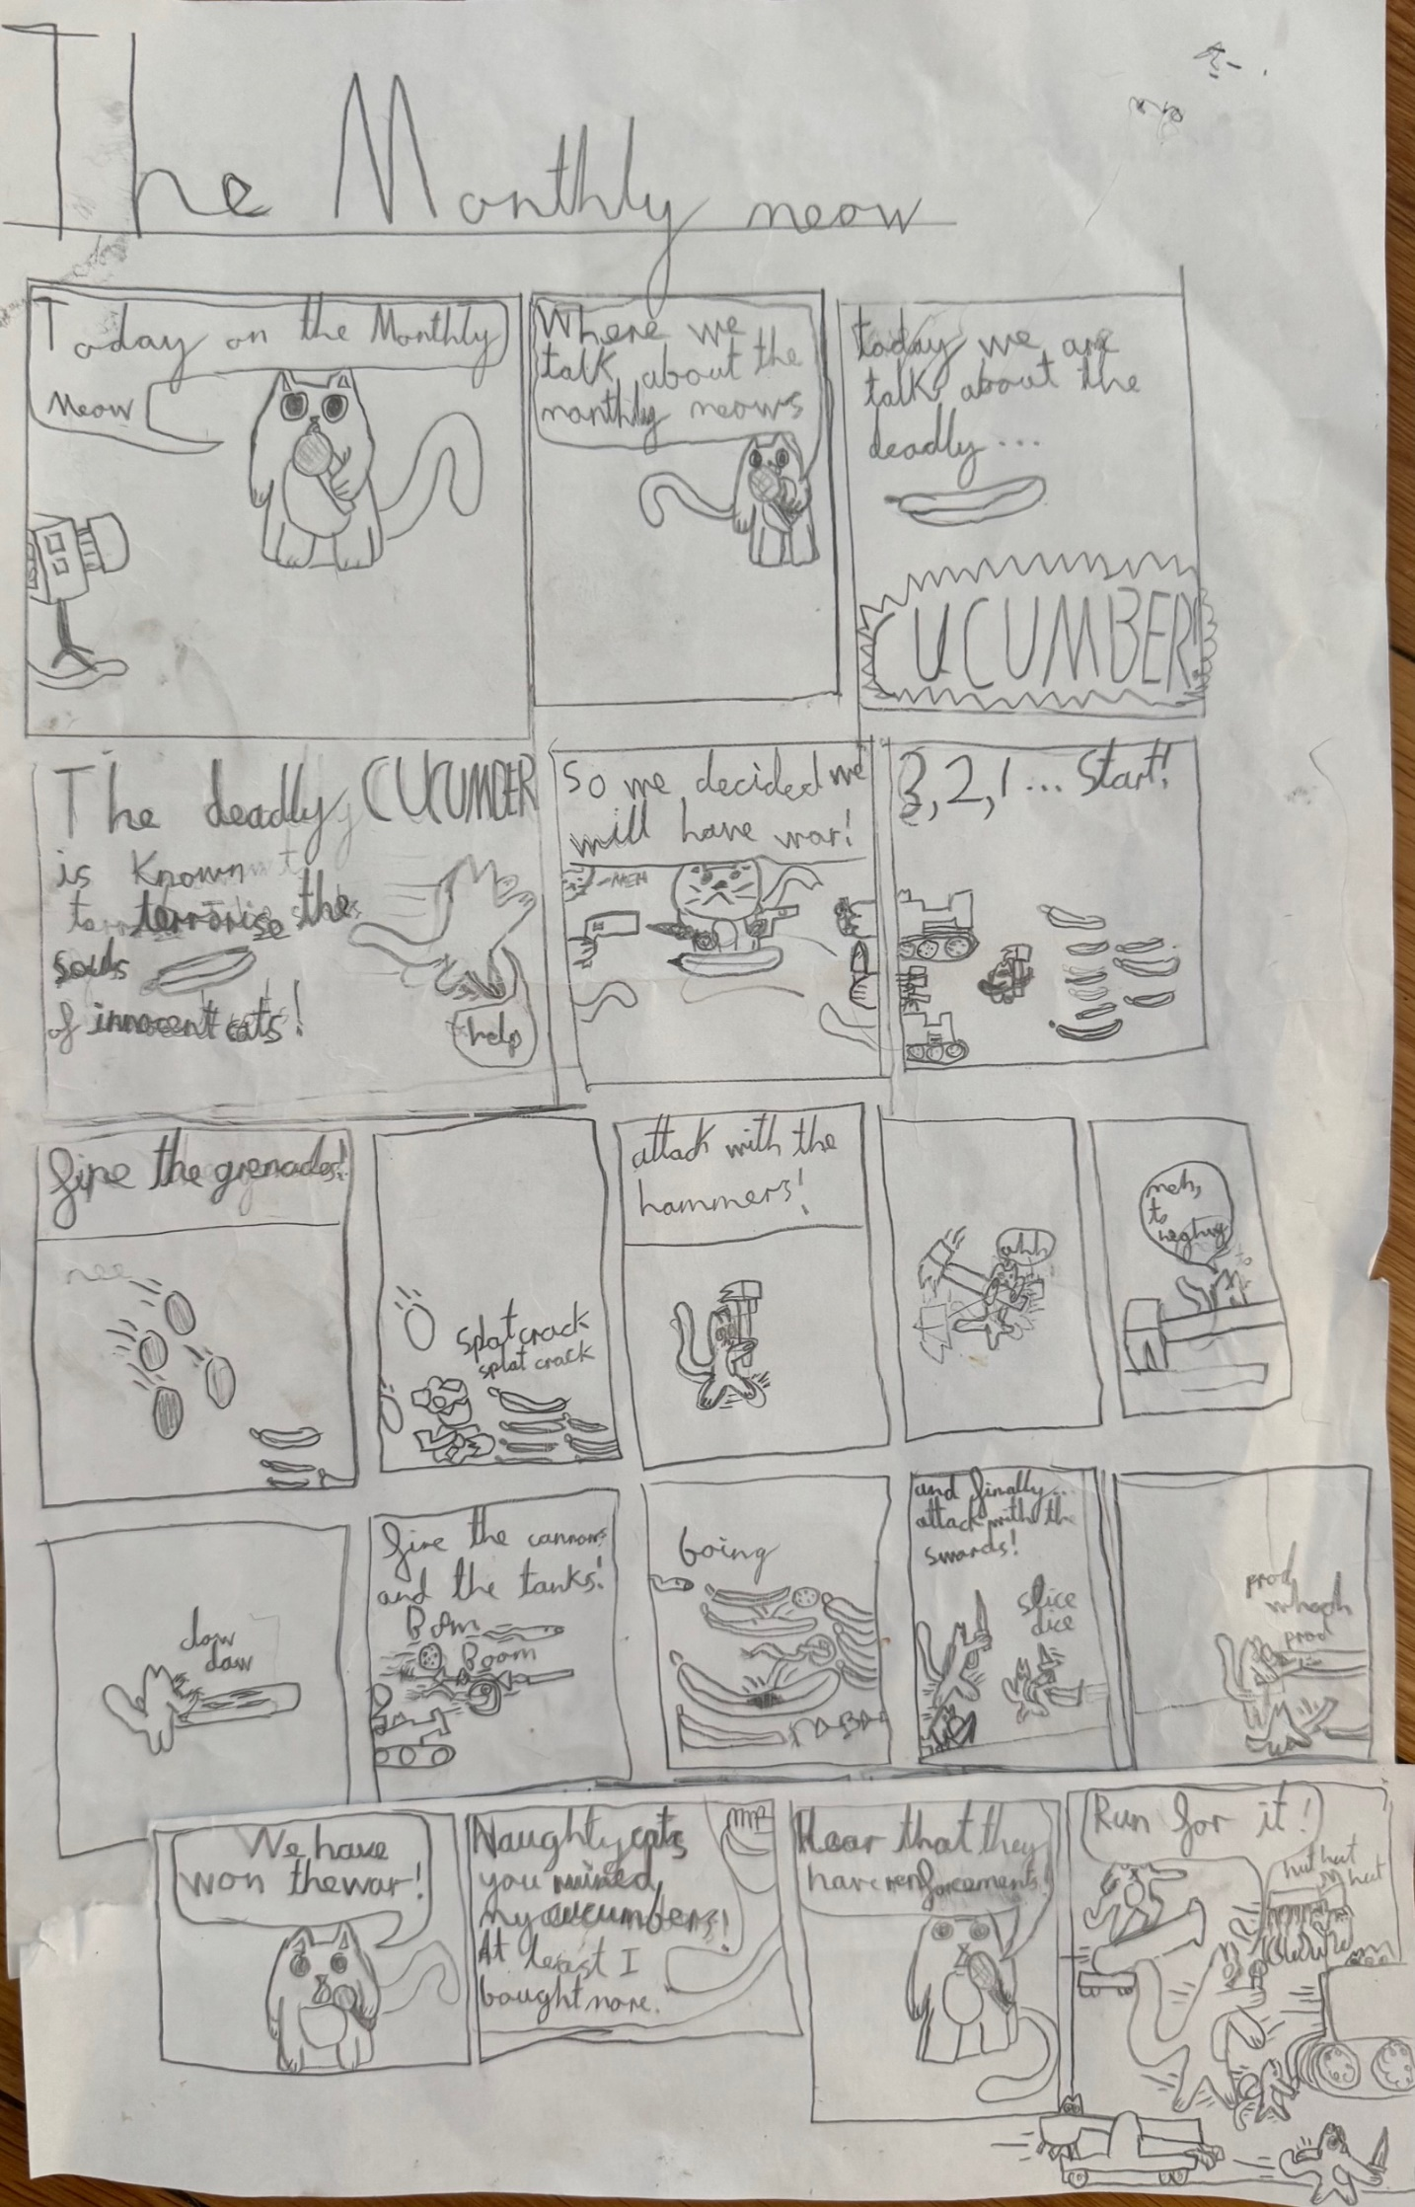
Wordsearch by William, Y2

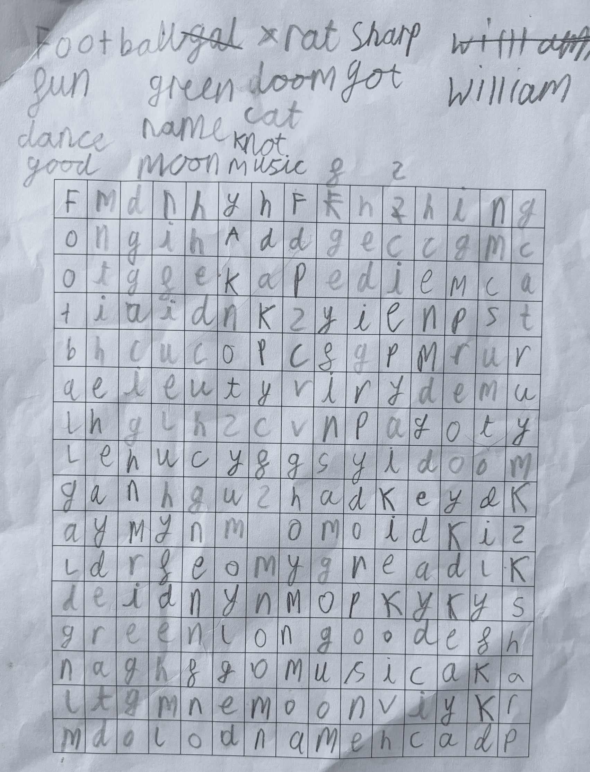

Fun wordsearchs by Hugo and Eliza, Y2
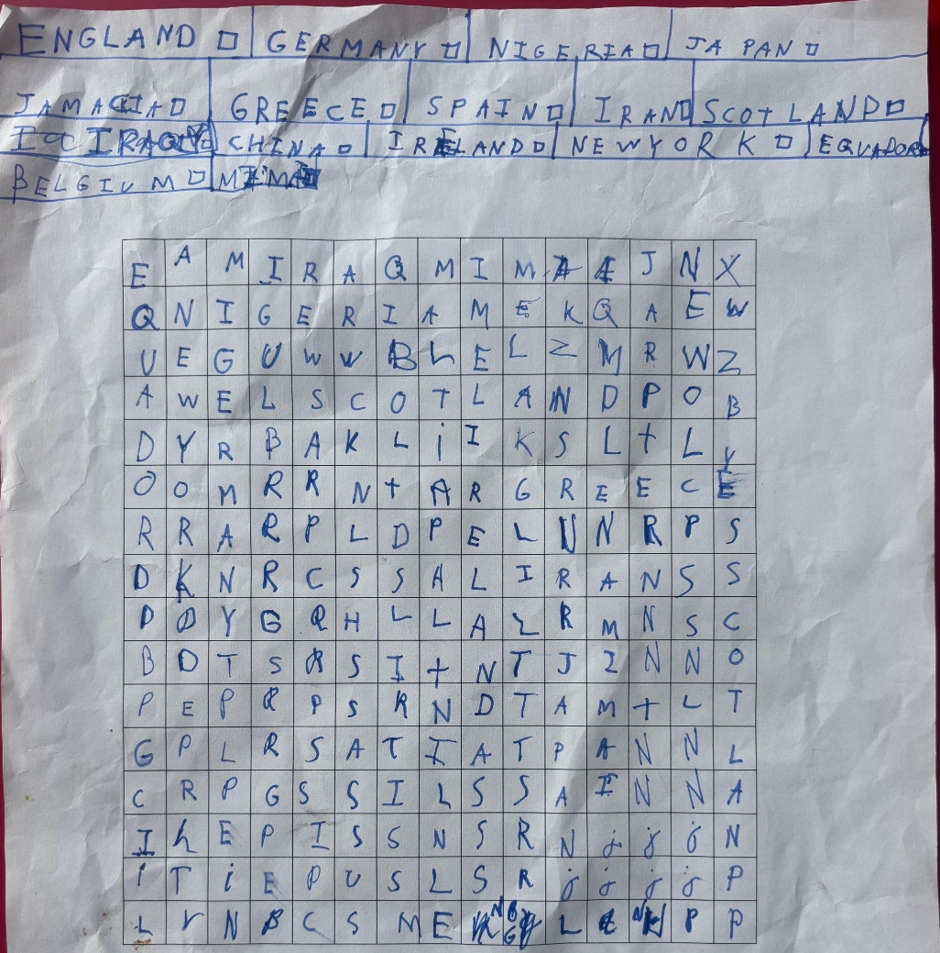
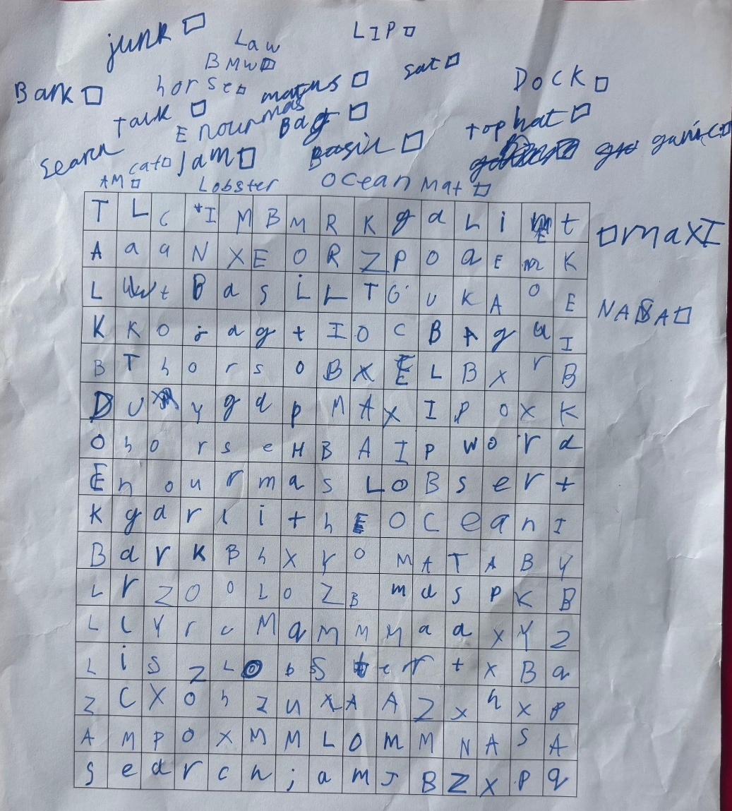
‘Our school’ wordsearch by Keira, Y1

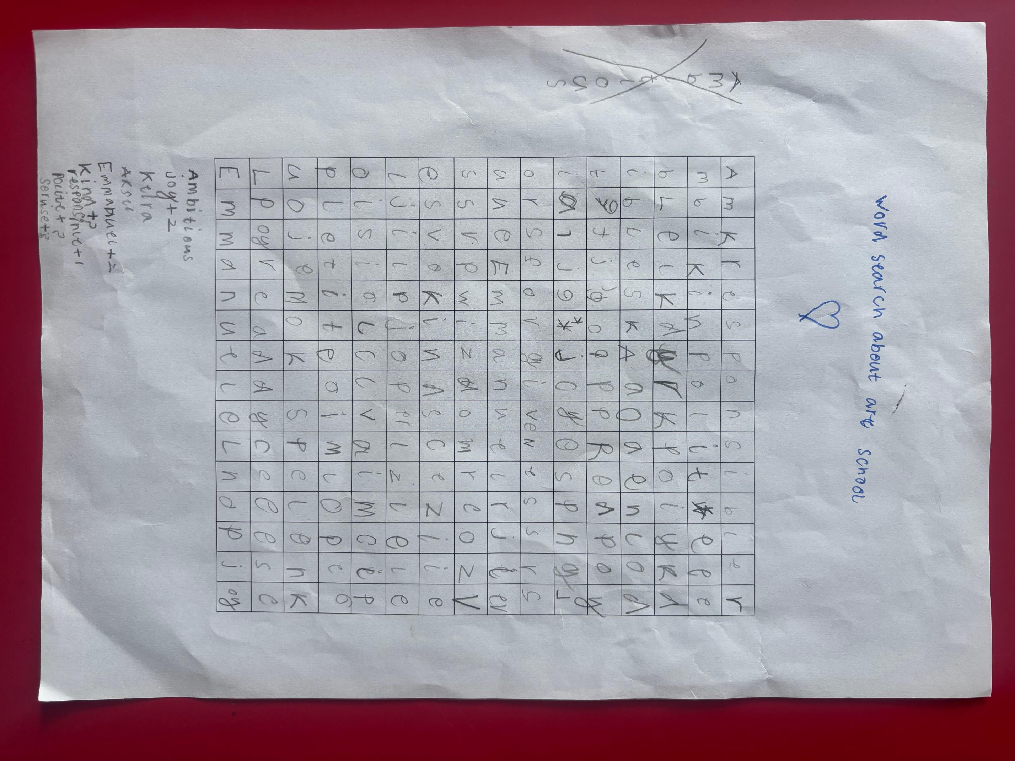

Answers
Aksel’s quiz
a.
Here is the algorithm for how to transform HEART INTO WHTRY.
H becomes W
E becomes H
A becomes T
R becomes Z
T becomes Y
Based on the above code,
HER would become WHZ
TEAR would become YHTZ
RAT would become ZTY.
b.
2 x 5 = 10
3 x 10 = 30
60 x 100 = 6000. This one is a little tricky. You can think of 60 times 100 as the same thing as 10 times 60, 10 times. Each time we multiply a number by 10, it is the same thing as adding a zero in the end (or pushing all place values up by 10). So 60 times 100 is the same thing as adding 2 zeros at the end because we are multiplying by 10 twice.
c.
i. Pluto used to be considered a planet until 2006, when it was reclassified as a dwarf planet because it is too small.
ii. They allow us to breathe air, without which we could not survive.
iii. Yes, tardigrades, also known as "water bears," can survive for up to 30 years without food or water!
iv. Generally, metal tends to last longer than wood because of its inherent resistance to decay, rot, and moisture damage.

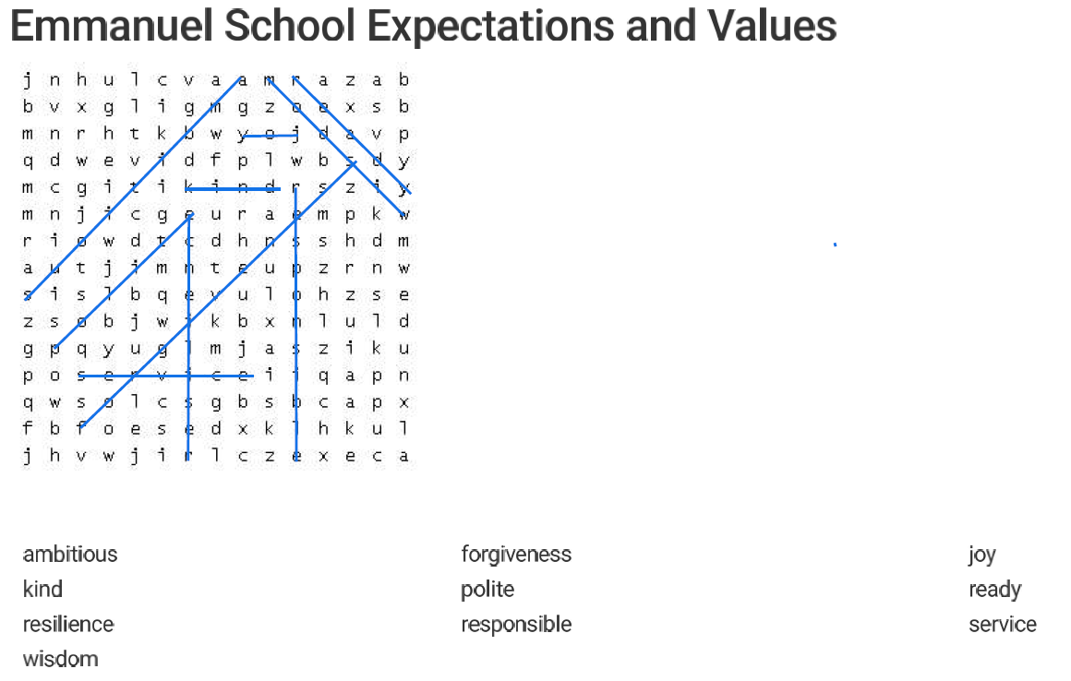
English quiz Answers
- question mark
- dazzling
- sheepish and bold
- assertive and confident

True or false quiz
- False
- False
- True
- False
- true

A big thank you to everyone who made this edition possible and we really hope you all enjoy reading it. If you would like to write or draw something for the next edition, you can give it to your Class Reps or hand it in on the Emmanuel Express Google Classroom page.

